***Doing Subnetting Backwards***

192.168.5.68/28

1. Convert the number of hosts to binary.
   1. /24
2. Reserve bits in the mask and find your increment.
   1. /28 = 11111111.11111111.11110000
3. Use increment to generate network ranges.
   1. 192.168.5.0
   2. 192.168.5.16
   3. 192.168.5.32
   4. 192.168.5.48
   5. 192.168.5.64 - 79
   6. 192.168.5.80

With the IP address 172.16.20.15/29, which of the following increments match the designated subnet?

172.16.20.15/29

11111111.11111111.11111000/29

172.16.20.15.0 – 7

172.16.20.15.8 – 15

Increment of 8

***Practical Reverse Engineering Examples***

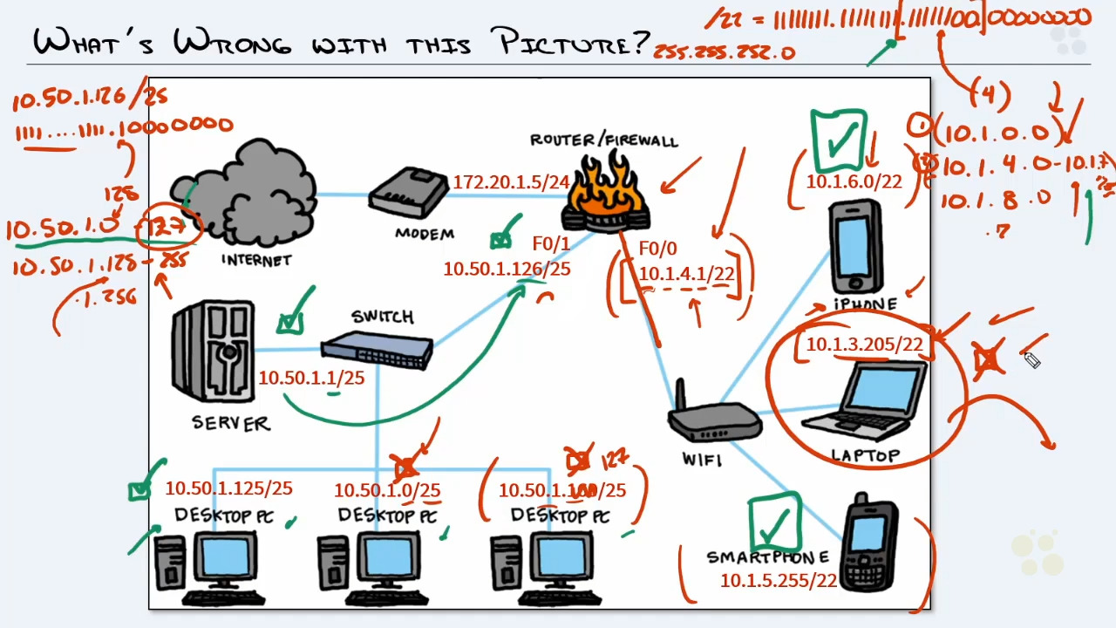

Your gateway has the IP address of 172.16.16.100/20. Which usable host IP address is NOT on the same network as the gateway?

11111111.11111111.11110000.00000000

172.16.0.0

172.16.16.0-172.16.31.255

172.16.32.0

So the answer is 172.16.32.255 because it is out of range

1. 172.16.31.254
2. 172.16.32.255
3. 172.16.16.12
4. 172.16.30.12

***What is VLSM?***

This is when you take multiple subnet problems and combine them into a single network. You need to stack it from the biggest network first then down to the smallest network.

When doing VLSM, it's best to start off with the smaller design requirements first. True or false?

FALSE

***VLSM SCENARIO***

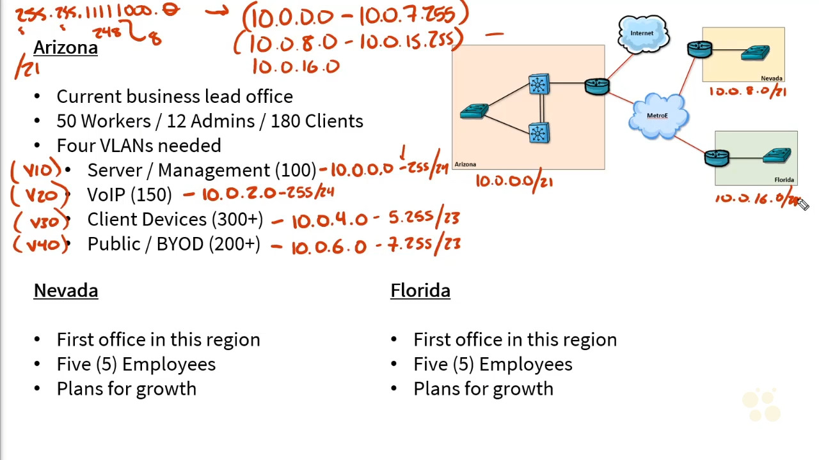

By using VLSM, let's help two sites, A and B, with different host requirements to use the 192.168.1.0/24 network. Which of the following networks will Site A (125 hosts) and B (45 hosts) use? (Choose two)

Site B: 192.168.1.x/26

Site A: 192.168.1.x/25